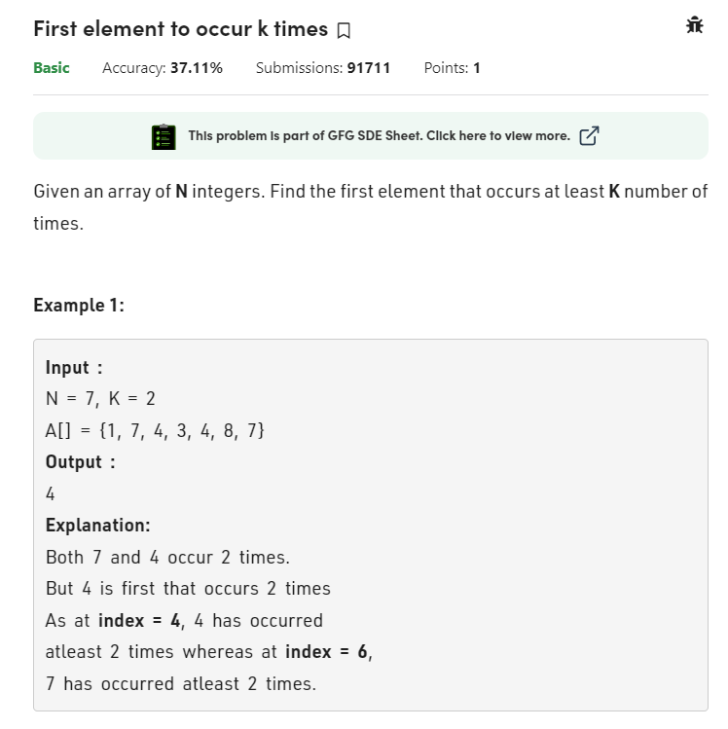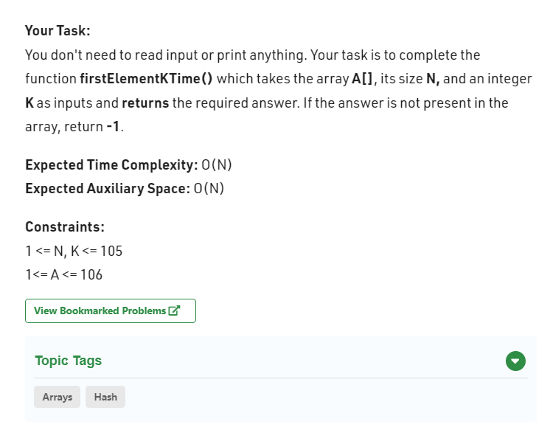class Solution

{

public int firstElementKTime(int[] a, int n, int k) {

int[] count = new int[100001];

for(int i : a){

count[i]++;

if(count[i]==k){

return i;

}

}

return -1;

}

}